**Islamabad:**

Faisal Mosque

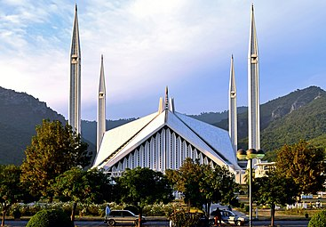

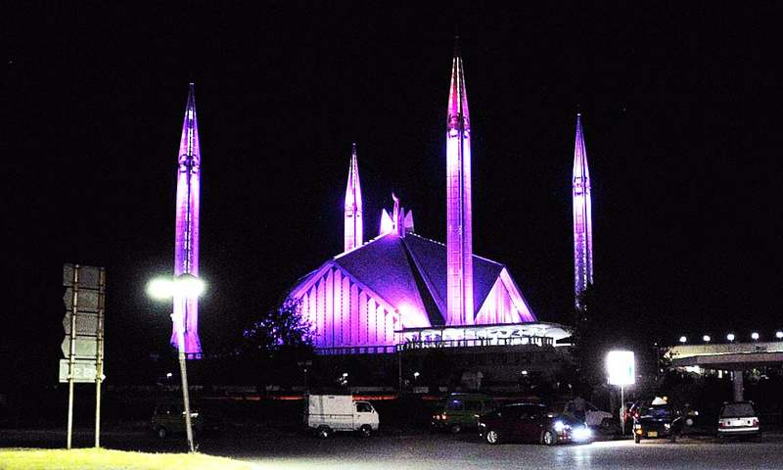

**Faisal Mosque** is a mosque in Islamabad, Pakistan. It is located on the foothills of Margalla Hills in Islamabad, the mosque features a contemporary design consisting of eight sides of concrete shell and is inspired by a Bedouin tent. The mosque is a major tourist attraction, and is referred as a contemporary and influential feature of Islamic architecture.